NAME: __________________________ DATE DUE: ____________
TEACHER: ________________________
/26
Year 11 Term 4 – Gases HOMEWORK SHEET No. 4
Success Criteria – revision on work so far

 | 1. Of the Scientists who have contributed to the current understanding of gas behaviour who, in your opinion, has made the most important contribution to our understanding of gases. Provide reason(s) for your decision.
/2
/4 | 2. List all of the mathematical formulas you know so far. Beside each write the conditions under which that formula can be applied.
/2 | 3. Write a question which could be solved by the correct application of Boyle’s law.
/1 | 4. Convert the following temperatures to ⁰C.  a) 293 K  b) 23 K
/3 |  | 5. Convert the following values to the units indicated in the brackets.
 |  | a) 23 mmHg (to kPa)  b) 42 ⁰C (to K)  c) 0.0013 atm (to kpa) | d) 3.56 cm³ (to L)  e) 0.092 m³ (to L)  f) 0.069 L (to mL)
/2 |  | 6. A hot can which is plunged into cold water will often crumple due to the sudden reduction in pressure. A 2000 ml can was heated to 100⁰C and then sealed. It was then plunged into a tank of water at a temperature of 0.5⁰C. Assuming the can would crumple at an internal pressure of 0.27 atmospheres, will it crumple under the conditions described? (Justify your answer)
/3 |  | 7. Which graph below correctly describes the relationship between Pressure and temperature for a sample of ideal gas at constant volume? Justify you choice.  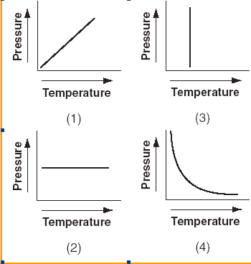
/2 |  | 8. What would be the change in volume for a perfectly elastic container if its temperature was increased by 25% - at a constant pressure? Justify your answer using your knowledge of the gas laws.
/3 |  | 9. An average pair of human lungs contains about 3.5 L of air before exhalation and about 3.0 L after exhalation. Assuming that air in your lungs is at 37°C and 1.0 atm, determine:  (a) the number of moles of air exhaled from your lungs  (b) The mass of air exhaled, assuming air is 80% nitrogen gas (N₂) and 20% Oxygen gas (O₂).
/4 |  | 10. A gas is known to be one of the following nitrogen oxides: NO, NO₂, N₂O4, or N₂O. It has a density of 1.96 g/L at 273 K and 1.00 atm. Determine its identity. Show your calculations

